PROJECT REPORT :
PREDICTING LIFE EXPECTANCY USING
MACHINE LEARNING
Name:R.Sri Durga
Github:https://github.com/SmartPracticeschool/llSPS-INT-2638-Predicting-Life-Expectancy-using-Machine-Learning

Contents :
1.INTRODUCTION
1.1 Overview
1.2 Purpose
2. LITERATURE SURVEY
2.1 Existing problem
2.2 Proposed solution
3. THEORITICAL ANALYSIS
3.1 Block diagram
3.2 Hardware / Software designing
3.2.1 Functional Requirements
3.2.2 Software Requirements
4. EXPERIMENTAL INVESTIGATIONS
5. FLOWCHART
6. RESULT
7. ADVANTAGES & DISADVANTAGES
8. APPLICATIONS
9. CONCLUSION
10. FUTURE SCOPE
11. BIBILOGRAPHY
APPENDIX
A. Source code

1. INTRODUCTION
1.1 Overview
The main objective of the project is to predict the life
expectancy of a person depending on several factors based on an
individual or the residing country. Factors like the GDP of the
country, health care facility system, quality of life, mental and
physical illness, age, gender, education and other regional,
demographic and economic factors are considered to predict the
lifespan of the person using machine learning algorithms.
Machine learning algorithms that can be used in this case are:
Regression, Decision Tree, Random Forest, Clustering
techniques, so that we can achieve high accuracy for our model.
1.2 Purpose
Predicting the life expectancy will give the country an idea of
the factors which can be improved to increase the lifespan of the
people living, like by improving the health care facilities or
immunization vaccines for infants. By making changes in
lifestyle, a person can live a long, healthy and good quality life.
This will also benefit the country by increasing manpower that
will contribute to the economical growth. We should take full
advantage of this new era advanced technology to improve the
future by predicting it in the present.
2. LITERATURE SURVEY
2.1 Existing Solution
We have reviewed existing works and techniques used in the
prediction of the human life expectancy, and reached a
conclusion that it is feasible for individuals using evolving
technologies and devices wearables and mobile health
monitoring devices. We have also identified that the factors used
for predicting were just personal causes and not related to the
surrounding, healthcare facilities, demographic, social, regional
and economical factors of the country he resides. These country
dependent factors can also be an important feature to predict the
life expectancy of an individual. So we need more data to
predict more accurately.
2.2 Proposed Solution
To get better insights and predict the life expectancy more
accurately, we need to consider some additional features such as
country or surrounding dependent features. The previous factors
were more human based but it is important to know the
economical, regional, social and demographic factors like the
GDP, population, education, immunizations, history of illness,
health care facility, funds allocated by the government, schemes,
medical expenditures like if it is very high then people will shy
away to get regular medical checkups, and many more.
Due to the large data, we will use IBM Cloud to build our model
which will increase the project efficiency.
We will be using the dataset : Life Expectancy by WHO from
Kaggle.

3. THEORITICAL ANALYSIS
3.1 Block diagram:
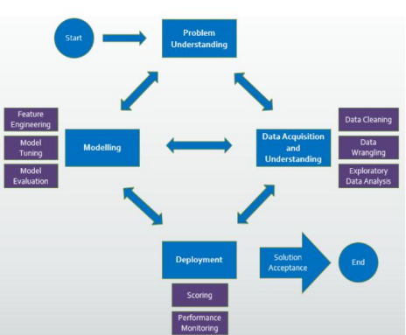

3.2 Hardware / Software designing:
Functional Requirements:
1. The dataset should be preprocessed before modelling.
2. Feature Engineering should be performed to select co-related
and integer values.
3. Appropriate machine learning algorithm should be used.
4. The project should be implemented using IBM Watson
Studio which should then connected to Node-Red App for UI
and deployed.
Software Requirements:
Python IDE, IBM Watson Studio, IBM Machine Learning
Services, IBM Cloud, Node-Red App, Excel.
4.EXPERIMENTAL INVESTIGATIONS
The model is first built using linear regression that had the R2
score of 0.82 and then random forest regressor was implemented,
which gave an R2 score of 0.96. So, this gives us an better
accuracy of the model.
- FLOWCHART
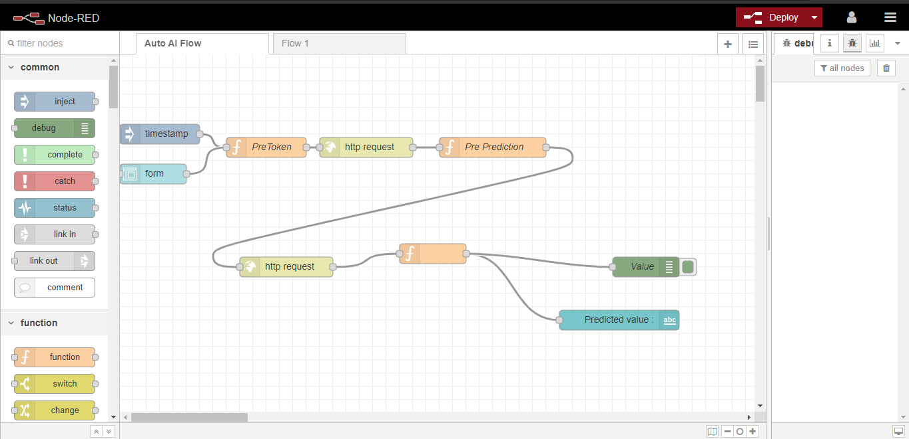
Node-Red Flow
6. RESULTS
User has to fill the form with various fields and the prediction
will come after clicking on the submit button.
7. ADVANTAGES & DISADVANTAGES
Advantages:
1. The life expectancy predictor will give important insights
and help people achieve good quality of life in future. The
country can plan and improve various healthcare facilities.
2. Benefit the country’s growth.
3. Advantages of using IBM Cloud: Easy to use and deploy,
easy to connect with UI, takes care of large storage space.
Disadvantages:
1. Requires internet connection.
2. User input is not saved in any database.
3. Input should be in range only to predict accurate values.
8. APPLICATIONS:
1. To analyze country’s growth statistics in future years.
2. To help government prepare life insurance policies for
people. This will benefit the people.
3. To analyze all the factors and plan out measures to increase
the life expectancy of the country.
9. CONCLUSION
Thus, we have developed a model that will predict the life
expectancy of a person living in a specific region. Various
factors like Adult Mortality, Population, Under 5 Deaths,
Thinness 1-5 Years, Alcohol, HIV, Hepatitis B, GDP,Percentage
Expenditure and many more play an important role in the
prediction. User can interact with the system via a simple user
interface which is in the form.
10. FUTURE SCOPE
The accuracy of the model can be increased. This can be done
by training more data. Also, the website can be added with
many more features to improve the user experience. The user
input can be connected to the database for future purposes.

11. BIBILOGRAPHY
https://bookdown.org/caoying4work/watsonstudio-workshop/jn.
html
https://developer.ibm.com/tutorials/how-to-create-a-node-red-st
arter-application/
https://github.com/SmartPracticeschool/llSPS-INT-1707-Predict
ing-Life-Expectancy-using-Machine-Learning
12. APPENDIX
A. Source code
import types
import numpy as np # for numeric calculation
import pandas as pd # for data analysis and manupulation
import matplotlib.pyplot as plt # for data visualization
import seaborn as sns # for data visualization
from sklearn.model_selection import train_test_split
from sklearn.linear_model import LinearRegression
from sklearn.ensemble import RandomForestRegressor
from sklearn.metrics import mean_squared_error
from sklearn.metrics import r2_score
from botocore.client import Config
import ibm_boto3
def __iter__(self): return 0
# @hidden_cell
# The following code accesses a file in your IBM Cloud Object Storage. It includes
your credentials.
# You might want to remove those credentials before you share the notebook.
client_82e38e728a2b4498b0106e3a414a28a9 = ibm_boto3.client(service_name='s3',
ibm_api_key_id='0yEJ4xOS-jcMr50Vx1CLVy4cPDOsvlpYXMlI4gXTAjFf',
ibm_auth_endpoint="https://iam.cloud.ibm.com/oidc/token",
config=Config(signature_version='oauth'),
endpoint_url='https://s3.eu-geo.objectstorage.service.networklayer.com')
body =
client_82e38e728a2b4498b0106e3a414a28a9.get_object(Bucket='lifeexpectancy-don
otdelete-pr-xhe5gejavgecm9',Key='Life Expectancy Data.csv')['Body']
# add missing __iter__ method, so pandas accepts body as file-like object
if not hasattr(body, "__iter__"): body.__iter__ = types.MethodType( __iter__, body )
# If you are reading an Excel file into a pandas DataFrame, replace `read_csv` by
`read_excel` in the next statement.
df= pd.read_csv(body)
df.head()
df.columns
df.info()
df.isna().sum()
df=df.fillna(df.mean())
df.isna().sum()
df.describe()
plt.figure(figsize=(12,9))
sns.heatmap(df.corr(), annot = True)
plt.title("Heatmap using correlation matrix", fontsize = 25)
d = {'Life expectancy ':1 , 'Adult Mortality':2 ,
'Alcohol':3 , 'percentage expenditure': 4, 'Hepatitis B': 5,
'Measles ' : 6, ' BMI ': 7, 'under-five deaths ' : 8, 'Polio' : 9, 'Total
expenditure' :10,
'Diphtheria ':11, ' HIV/AIDS':12, 'GDP':13, 'Population' :14,
' thinness 1-19 years' :15, ' thinness 5-9 years' :16,
'Income composition of resources' : 17, 'Schooling' :18, 'infant deaths':19}
plt.figure(figsize=(20,30))for variable,i in d.items():
plt.subplot(4,5,i)
sns.boxplot(df[variable],orient='v')
plt.title(variable)
plt.show()
plt.figure(figsize=(170,70))
sns.pairplot(df)
df.groupby('Country')['Life expectancy '].mean().sort_values(ascending=False)
country = df.groupby('Country')['Life expectancy
'].mean().sort_values(ascending=False)
country.plot(kind='bar', figsize=(60,20), fontsize=25)
plt.title("Life Expectancy",fontsize=40)
plt.xlabel("Country",fontsize=35)
plt.ylabel("Avg Life_Expectancy",fontsize=35)
plt.show()
sns.distplot(df['Life expectancy '])
df['Status'].unique()
df.groupby('Status')['Country'].count()
df.groupby('Status')['Life expectancy '].mean()
status_dummy=pd.get_dummies(df['Status'])
df.drop(['Status'],inplace=True,axis=1)
df=pd.concat([df,status_dummy],axis=1)
df.drop(['Country'],inplace=True,axis=1)
y= df['Life expectancy ']
df= df.drop('Life expectancy ',axis=1)
df.drop('Year',inplace=True,axis=1)
df
X_train, X_test, y_train, y_test = train_test_split(df, y, test_size=0.2,
random_state=20)
print(X_train.shape, y_train.shape)
print(X_test.shape, y_test.shape)
rfmodel = RandomForestRegressor(n_estimators = 30, random_state = 70)
rfmodel.fit(X_train, y_train)
pred= rfmodel.predict(X_test)
print("Training score:",rfmodel.score(X_train, y_train))
print("Testing Score:",rfmodel.score(X_test, y_test))
print("RMSE:",mean_squared_error(y_test,pred)**(0.5))
print("R2 score:",r2_score(y_test,pred))
R2 score with linear regression - 0.82
R2 score with random forest regressor - 0.96
sns.distplot(pred)
plt.scatter(pred,y_test)
!pip install watson-machine-learning-client
from watson_machine_learning_client import WatsonMachineLearningAPIClient
wml_credentials={
"apikey": "hegFSad-2z7u4FpBIV2YmbxVzVtBw5mDSj9tu1Fm3gRe",
"iam_apikey_description": "Auto-generated for key a56ec9b8-6827-4e45-b36d-b9d13b39c89d",
"iam_apikey_name": "wdp-writer",
"iam_role_crn": "crn:v1:bluemix:public:iam::::serviceRole:Writer",
"iam_serviceid_crn": "crn:v1:bluemix:public:iam-identity::a/99c1fd45ad82428e9ece808d7d5a71e3::serviceid:ServiceId-76a77ae6-9ef9-45f3-9d21-3f4ec8cdfa7e",
"instance_id": "014dfe4a-2ae7-4caa-9dad-35bbcda5a3ca",
"url": "https://eu-gb.ml.cloud.ibm.com"
}

